Christopher D. Cerf
Commissioner of Education

For Immediate Release:
Contact: Communications Department
973.733.7338

THOUSANDS ACROSS THE CITY PARTICIPATING IN
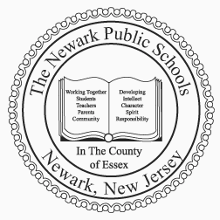
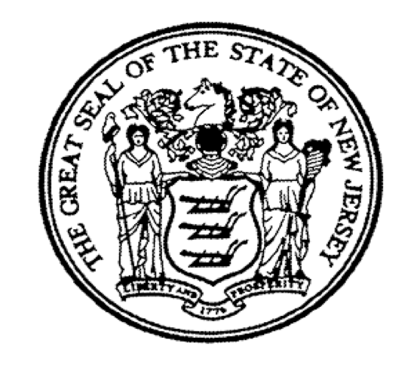
THE NEWARK PUBLIC SCHOOLS
Communications Department
2 Cedar Street
Newark, New Jersey 07102-3091
Phone: 973-733-7338
Fax: 973-733-7526

Cami Anderson
State District Superintendent

Matthew D. Frankel
Executive Director

ONE NEWARK’S SCHOOL CHOICE INITIATIVE

One Newark Enrolls Extended thru February 28th

- Next Enrollment Fair to Take Place February 11th at George Washington Carver Elementary School -

[Newark, NJ – February 5, 2014] – Far exceeding initial expectations and estimates, Newark Public Schools (NPS) announced today that nearly 5,800 families have begun applications for school year 2014-15 under the One Newark Enrolls initiative. For the first time, thousands of families are empowered to choose their own schools. Because of overwhelming demand and interest, NPS has extended the due date for One Newark Enrolls to February 28, 2014. Families may continue to submit an application online at www.newarkenrolls.org or by filling out a paper application that can be obtained from and submitted to any district school, participating charter school, or the NPS Central Office located at 2 Cedar Street.

“Newark families are embracing the opportunity to select a school that is best for their students,” stated Newark Public Schools Superintendent Cami Anderson. “We believe that students who are academically prepared and need to be challenged further, as well as students who are struggling, deserve excellent schools. As we have seen year after year, families are leaving schools that are failing and there is no reason why any family should accept a school that isn’t preparing their child for the future. One Newark Enrolls represents a collaboration between community-based partners, charter partners, funders, families, and educators.”

One Newark Enrolls is a first-of-a-kind universal enrollment system that aims to ensure more Newarkers have access to excellent schools. Through a preference structure that ensures high need students gain access to high performing schools, while also prioritizing equity, transparency, and access for all students in the city. Under One Newark Enrolls, every student will have the ability to change schools, though those who are content with their current school will remain there. The system will focus on grades where students enter or change schools: Pre-K, Kindergarten, Grade 5 and Grade 8.

(1 of 2)

This new enrollment structure provides all families:

• A single, fair, user-friendly application that eliminates barriers so all families have the opportunity to apply to high quality schools of their choice.

• The ability to prioritize schools they believe will best serve their own children.

• Clear and consistent information about all participating schools in Newark through fairs, local publications, websites like www.onewark.org and www.newarkenrolls.org, and open houses.

• A centralized way to voice concerns and receive support to ensure their children secure enrollment in a school that meets their needs

Launched just 25 days ago, all schools in NPS and participating charter partners have embarked on an extensive outreach plan to personally engage thousands of parents across the district. Over 1300 parents attended the first One Newark Enrolls school fair on January 11th. The One Newark Enrolls school fair at North Star Academy’s Fairmount campus on January 16th brought in over 200 families to learn more about their school options and the enrollment process. The One Newark Enrolls High School fair boasted over 200 attendees. The next One Newark Enrolls fair will take place on Tuesday, February 11th at 6 pm at George Washington Carver Elementary School located at 333 Clinton Place, Newark, NJ.

Families can also obtain more information about One Newark Enrolls at any Newark public school and participating charter public school. Open houses, meetings for families who have students with disabilities, information sessions, and school tours will be offered throughout the month of February.

# # #

